

**Integrating Asylum Seekers  
and Refugees**

into Higher Education

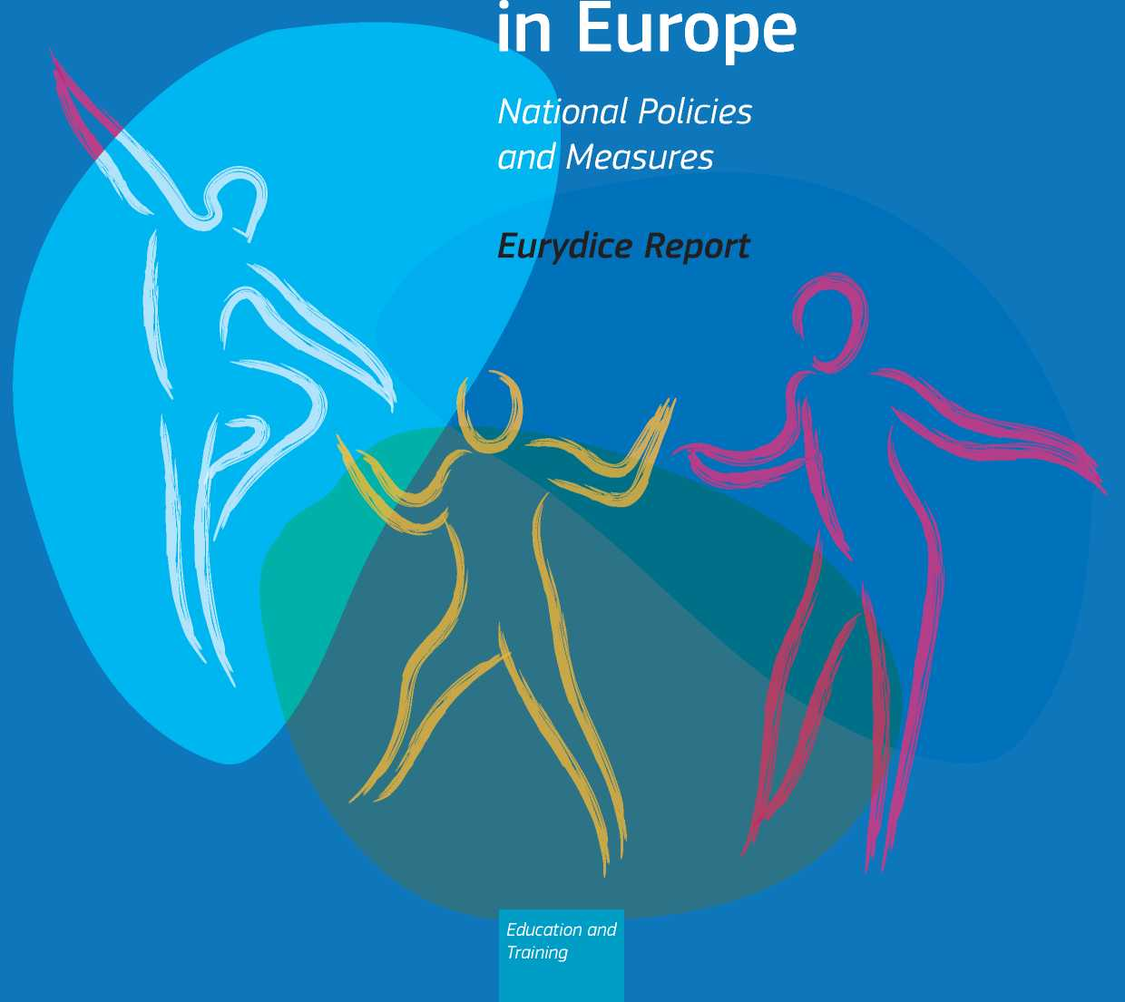

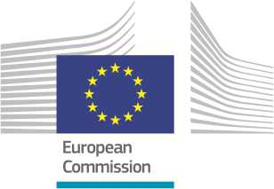

Integrating Asylum Seekers  
and Refugees  
into Higher Education  
in Europe:

National Policies and Measures

Eurydice Report

*Education and*

*Training*

This document is published by the Education, Audiovisual and Culture Executive Agency (EACEA, Education and Youth Policy Analysis).

**Please cite this publication as:**

European Commission/EACEA/Eurydice, 2019. *Integrating Asylum Seekers and Refugees into Higher Education in Europe: National Policies and Measures.* Eurydice Report. Luxembourg: Publications Office of the European Union.

Printed version EC-04-19-078-EN-C ISBN 978-92-9492-913-6 doi:10.2797/649493

PDF EC-04-19-078-EN-N ISBN 978-92-9492-916-7 doi:10.2797/548910

Text completed in January 2019.

© Education, Audiovisual and Culture Executive Agency, 2019.

Reproduction is authorized provided the source is acknowledged.

Education, Audiovisual and Culture Executive Agency Education and Youth Policy Analysis

Avenue du Bourget 1 (J-70 - Unit A7)

BE-1049 Brussels

Tel. +32 2 299 50 58

Fax +32 2 292 19 71

E-mail: [eacea-eurydice@ec.europa.eu](mailto:eacea-eurydice@ec.europa.eu)

Website:<http://ec.europa.eu/eurydice>

CONTENTS

**Table of Figures 3**

**Codes and Abbreviations 4**

**Introduction 5**

**1. Background Indicators 7**

1. Migratory flows in Europe 7
2. Asylum seekers in Europe 9

**2. Integrating Asylum Seekers and Refugees into Higher Education: Policies, Measures and Monitoring 13**

2.1. Policies and strategies for the integration of asylum seekers and refugees into higher education 13

* 1. Measures to support the integration of asylum seekers and refugees into higher education 15
  2. Monitoring of participation of asylum seekers and refugees in higher education 22

**Conclusions 24**

**Glossary 25**

**References 27**

**Acknowledgements 29**

**TABLE OF FIGURES**

Figure 1: Total annual immigration in the European Union, 2007-2016 7

Figure 2: Annual non-EU immigration in the European Union and EFTA countries, 2014, 2015 and 2016 (thousands) 8

Figure 3: Asylum applications (non-EU) in the European Union, 2008-2017 (thousands) 9

Figure 4: Countries of origin of (non-EU) asylum seekers in the European Union, 2016 and 2017 (thousands of first-time

applicants) 10

Figure 5: Number of (non-EU) asylum seekers in the European Union and EFTA Member States, 2016 and 2017

(thousands of first-time applicants) 11

Figure 6: Distribution by age of (non-EU) first-time asylum applicants in the EU and EFTA Member States, 2017 12

Figure 7: References to asylum seekers and/or refugees in top-level steering documents covering higher education,

2017/18 14

Figure 8: Large-scale measures to support the integration of asylum seekers and refugees into higher education,

2017/18 15

Figure 9: Areas covered by large-scale measures to support the integration of asylum seekers and refugees into higher

education, 2017/18 16

Figure 10: Implementation of article VII of the Lisbon Recognition Convention, 2017/18 19

Figure 11: Higher education access and participation measures targeting non-traditional learners, 2017/18 22

Figure 12: Monitoring of participation of asylum seekers and refugees in higher education, 2017/18 23

CODES AND ABBREVIATIONS

**Country codes**

|  |  |  |  |
| --- | --- | --- | --- |
| **EU/EU-28** | European Union | **PL** | Poland |
| **BE** | Belgium | **PT** | Portugal |
| **BE fr** | Belgium - French Community | **RO** | Romania |
| **BE de** | Belgium - German-speaking Community | **SI** | Slovenia |
| **BE nl** | Belgium - Flemish Community | **SK** | Slovakia |
| **BG** | Bulgaria | **FI** | Finland |
| **CZ** | Czech Republic | **SE** | Sweden |
| **DK** | Denmark | **UK** | United Kingdom |
| **DE** | Germany | **UK-ENG** | England |
| **EE** | Estonia | **UK-WLS** | Wales |
| **IE** | Ireland | **UK-NIR** | Northern Ireland |
| **EL** | Greece | **UK-SCT** | Scotland |
| **ES** | Spain | **EEA and candidate countries** | |
| **FR** | France | **AL** | Albania |
| **HR** | Croatia | **BA** | Bosnia and Herzegovina |
| **IT** | Italy | **CH** | Switzerland |
| **CY** | Cyprus | **IS** | Iceland |
| **LV** | Latvia | **LI** | Liechtenstein |
| **LT** | Lithuania | **ME** | Montenegro |
| **LU** | Luxembourg | **NO** | Norway |
| **HU** | Hungary | **RS** | Serbia |
| **MT** | Malta | **(*)** | The former Yugoslav Republic of Macedonia |
| **NL** | Netherlands | **TR** | Turkey |
| **AT** | Austria |  |  |

(*) Provisional code

**Statistics**

(:) Data not available

(-) Not applicable or zero

INTRODUCTION

Human history has been shaped by people moving to live in new places. The numbers of people living outside their countries of birth in today's societies are, however, much higher than in the past. In the European Union (EU) Member States, the number of people with citizenship of a non-member country on 1 January 2017 was 21.6 million, and there were 16.9 million persons with the citizenship of another EU Member State (Eurostat, 2018c). Among this broad group of migrants, asylum seekers and refugees, who have been obliged to leave their country, make up a relatively small percentage. However the rapid increase in numbers of asylum seekers entering Europe in the years 2015 and 2016 - largely as a result of the conflict in Syria - lead media and politicians to characterise the phenomenon as a migration or refugee crisis.

This report was planned in the wake of this phenomenon. The President of the European Commission, Jean-Claude Juncker, in his State of the Union address in September 2015 stated that 'the first priority today is and must be addressing the refugee crisis' (European Commission 2015, p. 6). While there has been enormous political attention to the way in which the situation has been addressed, one of the areas of public policy that clearly has a role to play is higher education. In particular, a high proportion of refugees are aged in the typical higher education population range (18-34) and among these a considerable number have been enrolled in higher education programmes in their home country.

While there is inevitably a strong potential demand for higher education among the refugee population, it cannot be taken for granted that this demand can be easily met. In many cases, there will be a need for potential students to learn the host country language and to adapt to the higher education system. This requires adequate information and guidance, as well as provision of adapted preparatory programmes. Refugees are also likely to be in need of considerable support - both psychological and financial. Meanwhile for the host country, there will be a need to assess and recognise learning that cannot be demonstrated through certificates. This also requires system-level planning and action.

The aim of this report is to assess how far national systems have developed in terms of being able to respond to the needs of asylum seekers and refugees.

**Content and structure of the report**

This report is divided into two main parts. The first one presents a selection of indicators on migratory flows which provide the context for the report. Building on the contextual data, the second part offers an overview of policies, strategies and measures that exist across European countries for the integration of asylum seekers and refugees into higher education. The report ends with a short section of conclusions.

**Data sources and methodology**

The report is mainly based on information gathered by the Eurydice Network during summer 2018. The data collection was based on a short questionnaire prepared by 'Erasmus+: Education and Youth Policy Analysis' - a unit of the Education, Audiovisual and Culture Executive Agency (EACEA). It 12

involved 38 Eurydice National Units, representing 35 countries (1) (2). The data gathered constitute the basis for Section 2 of the report.

(1) The number of Eurydice National Units is higher than the number of countries. This is because Belgium is covered by three Eurydice Units (French Community of Belgium, Flemish Community of Belgium and German-speaking Community of Belgium) and the United Kingdom by two Units (one covering England, Wales and Northern Ireland, and another one covering Scotland).

(2) Greece, Albania and the former Yugoslav Republic of Macedonia are members of the Eurydice Network, but they did not take part in this report.

The Eurydice data and indicators are generally qualitative. They capture top-level initiatives (policies, programmes and schemes) or information available to top-level authorities. They generally do not cover regional or local initiatives. The reference year for qualitative indicators is the academic year 2017/18.

The information submitted by Eurydice National Units was complemented by data from other sources, mainly Eurostat data, which constitute the basis for Section 1 of the report.

The preparation and drafting of the report was coordinated by the Erasmus+ unit (see above). The draft version of the report was submitted to Eurydice National Units for comments and validation in December 2018.

All those who have contributed are acknowledged at the end of the report.

1. BACKGROUND INDICATORS

Before examining policies for access of migrants to European higher education systems, it is essential to explore how immigration in Europe has evolved in recent years. Thus, this section presents a selection of indicators on migratory flows which provide the context for this thematic report. The analysis starts by looking at total immigration in the European Union (EU), before focusing on immigration from non-EU countries and, more specifically, on people who applied for international protection in an EU Member State (asylum seekers).

* 1. Migratory flows in Europe

Over the past decade, total annual immigration in the European Union has fluctuated between 3 million and 4.7 million people. As Figure 1 shows, from 2007 to 2009, there was a decrease in immigration of almost one million people over the two years (from around 4 million to around 3 million). From 2010, annual immigration began to rise gradually, culminating in the biggest annual increase of around 900 thousand people in 2015 - the year when 4.7 million people immigrated to an EU Member State. Immigration then dropped to 4.3 million in 2016.

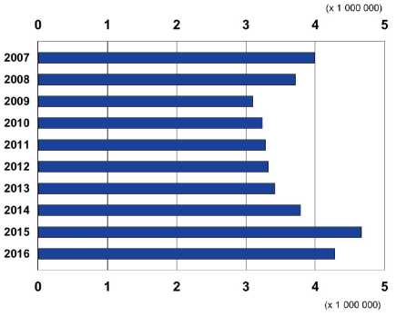

Figure 1: Total annual immigration in the European Union, 2007-2016

*Source:* Eurostat [migr_imm1ctz]. Data extracted in October 2018.

Explanatory notes

| **2007** | 3 987 446 |
| --- | --- |
| **2008** | 3 705 523 |
| **2009** | 3 097 091 |
| **2010** | 3 233 624 |
| **2011** | 3 273 680 |

| **2012** | 3 319 296 |
| --- | --- |
| **2013** | 3 416 826 |
| **2014** | 3 787 809 |
| **2015** | 4 659 324 |
| **2016** | 4 282 894 |

The figure shows annual immigration in the European Union (current EU-28 countries), and includes both intra-EU immigration and immigration from outside the EU.

**Country-specific notes**

**Belgium**: Data missing for 2008 and 2009.

**Bulgaria**: Data missing for 2008-2011.

**Romania**: Data missing for 2007.

While not depicted on a specific figure, the country data indicate that in 2016, Germany recorded the largest total number of immigrants (slightly over one million), followed by the United Kingdom (589.0 thousand), Spain (414.7 thousand), France (378.1 thousand) and Italy (300.8 thousand) (3). During the same reference year, Germany also recorded the highest number of emigrants (533.8 thousand), i.e. people who ceased to have their usual residence in Germany. It was followed by the United Kingdom (340.4 thousand emigrants in 2016), Spain (327.3 thousand), France (309.8 thousand), Poland (236.4 thousand) and Romania (207.6 thousand) (4). Overall, in 2016, 21 EU Member States reported more immigration than emigration. Bulgaria, Croatia, Latvia, Lithuania,

1. Eurostat [migr_imm1ctz]. Data extracted in October 2018.
2. Eurostat [migr_emi2]. Data extracted in October 2018. Poland, Portugal and Romania were the only EU countries where the number of emigrants outnumbered the number of immigrants (5).

The total annual immigration depicted in Figure 1 refers to various nationality profiles: European Union citizens who migrated to a different EU Member State; citizens of non-EU countries who immigrated into the EU; people who migrated to an EU Member State where they had citizenship (for example, returning nationals or nationals born abroad); as well as stateless people.

Figure 2 focuses on recent migratory flows from outside the EU, looking at the number of citizens of non-EU countries who immigrated to the EU and EFTA countries between 2014 and 2016. The evolution for the EU as a whole echoes the pattern depicted in Figure 1: between 2014 and 2015, there was a substantial increase in the number of people from outside the EU who immigrated to the

EU - from 1.6 million to 2.4 million -, and this was followed by a drop in 2016, when around 2 million citizens of a non-EU country immigrated to the EU.

At the country level, Germany recorded the largest number of immigrants from non-EU countries during the three reference years (372.4 thousand in 2014, almost 1 million in 2015, and 507.0 thousand in 2016). It was followed by the United Kingdom (265.4 thousand in 2016), Spain (235.6 thousand in 2016), Italy (200.2 thousand in 2016) and France (158.2 thousand in 2016).

Figure 2: Annual non-EU immigration in the European Union and EFTA countries, 2014, 2015 and 2016 (thousands)

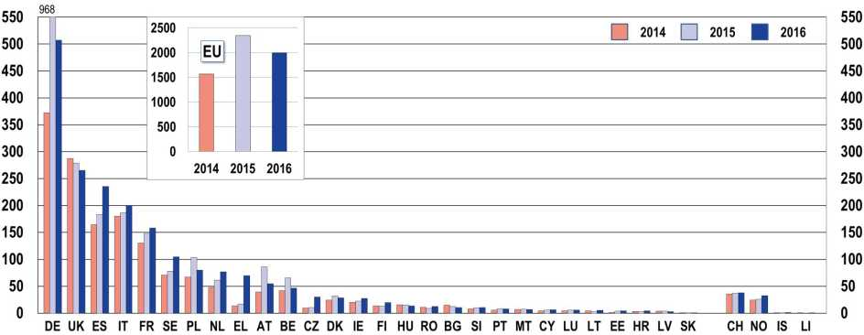

|  |  |  |  |  |  |  |  |  |  |  |  |  |  |  |  |  |  |
| --- | --- | --- | --- | --- | --- | --- | --- | --- | --- | --- | --- | --- | --- | --- | --- | --- | --- |
|  | **EU** | **DE** | **UK** | **ES** | **IT** | **FR** | **SE** | **PL** | **NL** | **EL** | **AT** | **BE** | **CZ** | **DK** | **IE** | **FI** | **HU** |
| **2014** | 1 565.7 | 372.4 | 287.1 | 164.4 | 180.3 | 130.4 | 70.7 | 67.0 | 47.8 | 13.5 | 39.4 | 41.6 | 9.4 | 24.5 | 20.3 | 13.6 | 15.5 |
| **2015** | 2 345.9 | 967.5 | 278.6 | 183.7 | 186.5 | 148.7 | 78.2 | 103.9 | 61.4 | 17.5 | 86.5 | 65.8 | 10.6 | 32.3 | 22.5 | 13.1 | 15.2 |
| **2016** | 1 993.3 | 507.0 | 265.4 | 235.6 | 200.2 | 158.2 | 104.4 | 80.1 | 76.7 | 69.5 | 54.5 | 46.5 | 29.9 | 28.6 | 27.2 | 19.6 | 13.3 |
|  | **RO** | **BG** | **SI** | **PT** | **MT** | **CY** | **LU** | **LT** | **EE** | **HR** | **LV** | **SK** |  | **CH** | **NO** | **IS** | **LI** |
| **2014** | 10.9 | 15.3 | 8.0 | 5.9 | 6.7 | 4.0 | 4.4 | 4.1 | 1.2 | 3.5 | 3.5 | 0.4 |  | 35.7 | 24.3 | 0.6 | 0.2 |
| **2015** | 9.0 | 12.9 | 9.9 | 8.6 | 7.5 | 5.9 | 6.1 | 2.9 | 3.7 | 3.0 | 3.8 | 0.7 |  | 37.4 | 26.0 | 0.7 | 0.2 |
| **2016** | 12.3 | 10.6 | 10.4 | 7.8 | 6.7 | 6.5 | 5.6 | 5.2 | 4.2 | 4.0 | 2.9 | 0.6 |  | 37.6 | 32.4 | 1.1 | 0.2 |

*Source:* Eurostat [migr_imm1ctz]. Data extracted in October 2018.

**Explanatory note**

Countries are sorted according to non-EU immigration in 2016.

1. Eurostat [migr_imm1ctz] and [migr_emi2]. Data extracted in October 2018.
   1. Asylum seekers in Europe

Among persons who immigrated to the European Union, some applied for international protection. As Figure 3 shows, there was a gradual increase in the number of asylum applications within the EU between 2008 and 2012, after which the number of asylum seekers rose at a much more rapid pace, with 431.1 thousand applications in 2013, 627.0 thousand in 2014 and just over 1.3 million in 2015. In 2016, slightly under 1.3 million citizens of non-EU countries applied for international protection in the EU Member States, while in 2017, the number dropped to 704.6 thousand.

Most asylum applicants in the EU were 'first-time applicants', i.e. persons who lodged an application for asylum for the first time in a given EU Member State. The figure for 2017 refers to 649.9 thousand first-time applicants, which is a decrease of around 560 thousand applicants compared with the year before. There was also a slight decrease of around 50 thousand first-time applicants between 2015 and 2016 - the two years during which the number of first-time applicants was the highest over the last decade.

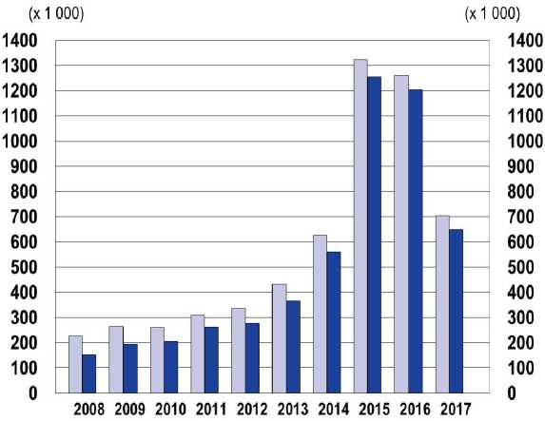

Figure 3: Asylum applications (non-EU) in the European Union, 2008-2017 (thousands)

*Source:* Eurostat, 2018a (the source refers to data extracted in April 2018).

|  | □ | □ |
| --- | --- | --- |
|  | Total  (x 1000) | First-time applicants  (x 1000) |
| **2008** | 225.2 | 152.9 |
| **2009** | 263.8 | 195.8 |
| **2010** | 259.4 | 206.9 |
| **2011** | 309.0 | 263.2 |
| **2012** | 335.3 | 278.3 |
| **2013** | 431.1 | 367.8 |
| **2014** | 627.0 | 562.7 |
| **2015** | 1322.8 | 1257.0 |
| **2016** | 1260.9 | 1206.1 |
| **2017** | 704.6 | 649.9 |

Syria has been the main country of citizenship of asylum seekers in the EU during recent years (6). Yet, while keeping this position, the number of Syrian first-time asylum applicants in the EU dropped from 334.9 thousand in 2016 to 102.4 thousand in 2017 (see Figure 4). Syria was followed by Iraq (47.5 thousand in 2017; 127.1 thousand in 2016) and Afghanistan (43.6 thousand in 2017; 183.0 thousand in 2016).

1. Syria has held this position since 2013 (Eurostat, 2018a).

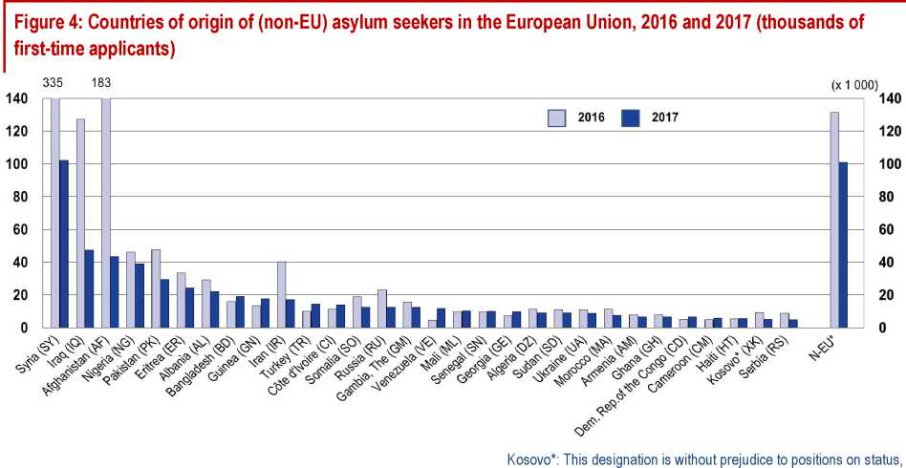

and is in line with UNSCR 1244/1999 and the ICJ Opinion on the Kosovo Declaration of Independence. N-EU* = Other non-EU

(x 1 000)

|  |  |  |  |  |  |  |  |  |  |  |  |  |  |  |  |  |
| --- | --- | --- | --- | --- | --- | --- | --- | --- | --- | --- | --- | --- | --- | --- | --- | --- |
|  | **SY** | **IQ** | **AF** | **NG** | **PK** | **ER** | **AL** | **BD** | **GN** | **IR** | **TR** | **CI** | **SO** | **RU** | **GM** | **VE** |
| **2016** | 334.9 | 127.1 | 183.0 | 46.3 | 47.6 | 33.4 | 29.2 | 16.0 | 13.5 | 40.2 | 10.1 | 11.2 | 19.0 | 23.1 | 15.7 | 4.7 |
| **2017** | 102.4 | 47.5 | 43.6 | 39.1 | 29.6 | 24.4 | 22.1 | 19.3 | 17.7 | 17.3 | 14.6 | 14.0 | 12.7 | 12.6 | 12.5 | 11.9 |
|  | **ML** | **SN** | **GE** | **DZ** | **SD** | **UA** | **MA** | **AM** | **GH** | **CD** | **CM** | **HT** | **XK** | **RS** | **N-EU** |  |
| **2016** | 9.5 | 9.5 | 7.3 | 11.2 | 11.1 | 11.1 | 11.2 | 7.7 | 7.8 | 5.2 | 4.9 | 5.3 | 9.2 | 8.9 | 131.5 |
| **2017** | 10.3 | 10.2 | 9.9 | 9.2 | 9.2 | 8.9 | 7.8 | 6.8 | 6.7 | 6.6 | 5.9 | 5.6 | 5.3 | 5.1 | 101.1 |

*Source:* Eurostat, 2018a (the source refers to data extracted in April 2018).

**Explanatory notes**

See Glossary for the definition of 'first-time asylum applicant'.

Countries are sorted according to the number of first-time applicants in 2017.

As far as reception countries are concerned, in 2017, Germany recorded the largest number of first­time asylum applicants among all the EU Member States: 198.3 thousand (see Figure 5), which represents around 30 % of all first-time applicants in the EU. It was followed by Italy (126.6 thousand), France (91.1 thousand), Greece (57.0 thousand), the United Kingdom (33.3 thousand) and Spain (30.4 thousand).

While recording the largest number of asylum seekers in the EU, Germany also registered the largest relative decreases in first-time applicants between 2016 and 2017 (-73 %; or 524 thousand fewer in 2017 than in 2016). Other countries recording a substantial decrease in the number of first-time applicants (difference of at least five thousand first-time applicants) were Hungary (25.1 thousand fewer), Austria (17.7 thousand fewer), Bulgaria (15.5 thousand fewer), Switzerland (9.2 thousand fewer), Poland (6.8 thousand fewer) and the United Kingdom (5.9 thousand fewer).

In contrast, some countries recorded a substantial increase in applications between 2016 and 2017, namely Spain (14.9 thousand more first-time applications in 2017 than in 2016), France (14.3 thousand more), Greece (7.1 thousand more) and Italy (5.4 thousand more).

Figure 5: Number of (non-EU) asylum seekers in the European Union and EFTA Member States, 2016 and 2017 (thousands of first-time applicants)

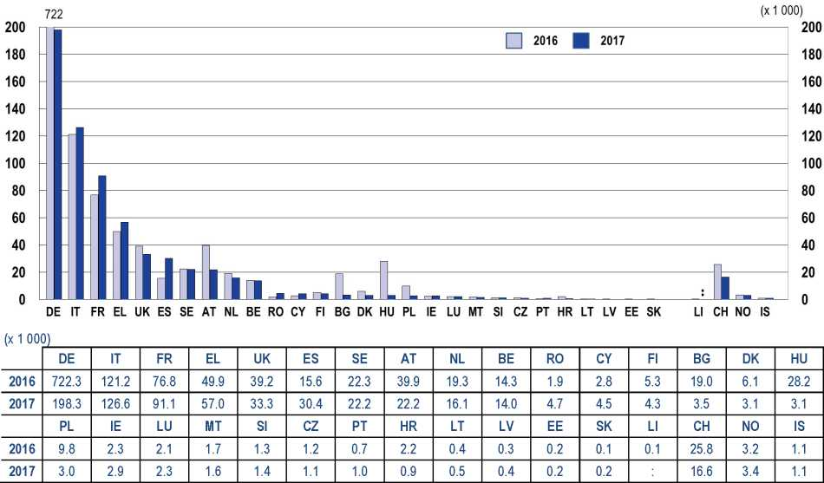

*Source:* Eurostat, 2018a (the source refers to data extracted in April 2018).

Explanatory notes

See Glossary for the definition of 'first-time asylum applicant'.

Countries are sorted according to the number of first-time applicants in 2017.

In terms of age structure, a substantial proportion of first-time asylum applicants are aged between 18 and 34, i.e. the age-range closely associated with higher education studies. Indeed, as shown in Figure 6, in 2017, slightly more than half of first-time applicants (51.5 %) in the EU were in this age group. The highest share of first-time applicants aged between 18 and 34 - more than 60 % - was recorded in Italy (77 %), Croatia (63.6 %) and Cyprus (63.1 %). In contrast, Estonia, Austria, Hungary, Poland and Germany registered only up to 40 % of first-time applicants between 18 and 34 years. These five countries recorded a high share (more than 40 %) of applicants under the age of 18. First­time asylum applicants aged between 35-64 years accounted for 17 % of applicants in the EU in 2017, with the Czech Republic recording the highest share of applicants in this age group (36.8 %).

Figure 6: Distribution by age of (non-EU) first-time asylum applicants in the EU and EFTA Member States, 2017

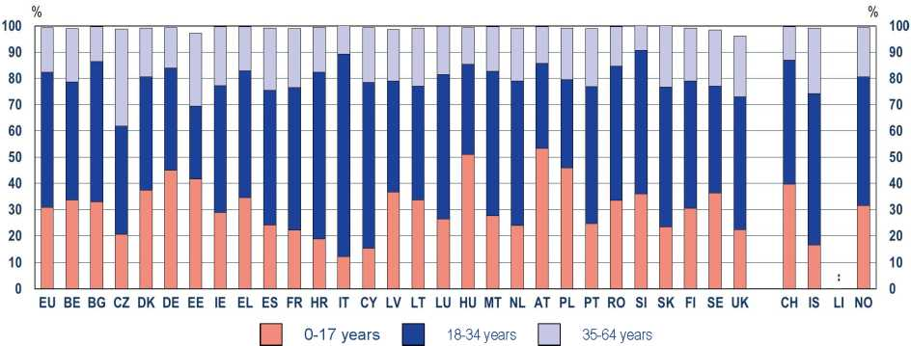

|  |  |  |  |  |  |  |  |  |  |  |  |  |  |  |  |  |  |
| --- | --- | --- | --- | --- | --- | --- | --- | --- | --- | --- | --- | --- | --- | --- | --- | --- | --- |
|  | **EU** | **BE** | **BG** | **CZ** | **DK** | **DE** | **EE** | **IE** | **EL** | **ES** | **FR** | **HR** | **IT** | **CY** | **LV** | **LT** | **LU** |
| **0-17 years** | 30.8 | 33.6 | 32.9 | 20.6 | 37.3 | 45.0 | 41.7 | 28.9 | 34.6 | 24.0 | 22.1 | 18.8 | 12.2 | 15.3 | 36.6 | 33.7 | 26.3 |
| **18-34 years** | 51.5 | 45.0 | 53.6 | 41.2 | 43.2 | 38.8 | 27.8 | 48.3 | 48.3 | 51.5 | 54.3 | 63.6 | 77.0 | 63.1 | 42.3 | 43.3 | 55.2 |
| **35-64 years** | 17.0 | 20.4 | 13.1 | 36.8 | 18.6 | 15.5 | 27.8 | 22.5 | 16.7 | 23.6 | 22.6 | 17.0 | 10.7 | 20.9 | 19.7 | 22.1 | 18.3 |
|  | **HU** | **MT** | **NL** | **AT** | **PL** | **PT** | **RO** | **SI** | **SK** | **FI** | **SE** | **UK** |  | **CH** | **IS** | **LI** | **NO** |
| **0-17 years** | 51.0 | 27.6 | 23.9 | 53.2 | 45.9 | 24.6 | 33.5 | 35.9 | 23.3 | 30.4 | 36.3 | 22.4 |  | 39.7 | 16.4 |  | 31.5 |
| **18-34 years** | 34.3 | 55.0 | 55.1 | 32.4 | 33.6 | 52.2 | 51.1 | 54.7 | 53.3 | 48.6 | 40.6 | 50.5 |  | 47.2 | 57.7 |  | 49.1 |
| **35-64 years** | 14.0 | 17.1 | 20.1 | 14.0 | 19.6 | 22.2 | 15.1 | 9.4 | 23.3 | 20.2 | 21.5 | 23.2 |  | 12.7 | 24.9 |  | 18.7 |

*Source:* Eurostat, 2018a (the source refers to data extracted in April 2018).

**Explanatory notes**

See Glossary for the definition of 'first-time asylum applicant'.

The figure does not include first-time asylum applicants aged 65 and over, and applicants of an unknown age.

Not all asylum applicants in the EU acquire a refugee or a comparable international protection status. More specifically, in 2017, out of around 1 million first-instance decisions that were issued in the EU Member States, 444 thousand (46 %) resulted in a positive outcome (7). An additional 95 thousand positive decisions were issued as a result of an appeal or review (36 % of final decisions were positive) (8). This means that around half a million citizens of non-EU countries received an international protection status in the EU in 2017.

Overall, the evolution of immigration in the EU over the past years raises a number of questions related to higher education in the Member States. Are European higher education systems prepared to react to recent developments related to numbers of newly arrived immigrants from non-EU countries? Are there structures and services in place allowing the evaluation and recognition of learning achievements acquired outside the EU, including undocumented learning achievements? Are there any large-scale policies or measures aiming to facilitate access of newly arrived immigrants to higher education? The remainder of this report aims to address these questions.

1. Eurostat [migr_asydcfsta]. Data extracted in October 2018.
2. Eurostat [migr_asydcfina]. Data extracted in October 2018.
3. INTEGRATING ASYLUM SEEKERS AND REFUGEES INTO HIGHER EDUCATION: POLICIES, MEASURES AND MONITORING

As outlined in the first part of this report, annual non-EU immigration into the European Union was particularly high in 2015 and 2016, when around 2.3 and 2 million non-EU citizens immigrated to the EU. During these two years, almost 2.6 million non-EU citizens applied for asylum in the EU, with Syria being their main country of citizenship. In 2017, around half a million non-EU citizens received refugee or comparable international protection status in the EU.

A substantial proportion of asylum applicants in the EU - around 50 % - are aged between 18 and 34, i.e. the age-range closely associated with higher education studies. They may be motivated to enter higher education, or could have been studying in higher education before leaving their country. They may or may not be able to document their previous study achievements. For this reason, it is important to examine which policy approaches and measures exist across Europe to support the integration of asylum seekers and refugees into higher education. This topic is the main focus of this section.

2.1. Policies and strategies for the integration of asylum seekers and refugees into higher education

Top-level authorities may apply various strategic approaches for the integration of asylum seekers and refugees into higher education. These may be stipulated in a range of official documents, including legislation, national strategies, action plans, 'white papers', etc. Countries were asked to report on these documents, which are considered under the generic term, 'top-level steering documents'.

Figure 7 shows where countries have top-level steering documents that refer explicitly to asylum seekers and/or refugees. It indicates that in 22 systems top-level steering documents covering higher education mention asylum seekers and refugees, while an almost equal number (19 systems) say nothing. However, among the systems where higher education steering documents mention asylum seekers and refugees, there are very few that outline any significant top-level policy or strategy. Indeed in some cases asylum seekers and refugees are mentioned simply to point out that responsibility for policy is devolved to another level of decision-making, such as higher education institutions.

Germany stands out among all European countries as having the most comprehensive policy approach, with a strategy developed in 2015 (KMK, 2015) outlining national measures for the integration of asylum seekers and refugees into the German higher education system. The main focus of the strategy is to facilitate the path into higher education for those asylum seekers and refugees who are motivated and with the aptitude to study, or who were previously studying in higher education before coming to Germany. There are a number of actions addressing recognition of qualifications and prior learning, bridging programmes, guidance and counselling services and financial support. The strategy also includes quantitative targets for providing new places in foundation programmes at the rate of 2 400 per year until a maximum of 10 000 places are opened. However, since rolling out the programme, the annual number has more than quadrupled to 10 400 places. The strategy is fully costed, and has a clear budget allocation.

In comparison to Germany, other countries focus on a more limited sphere of policy action and tend to include higher education within wider strategies on migration. Norway, Sweden and Denmark outline several higher education policy areas - recognition of educational qualifications, and supporting language learning - with the goal of facilitating smooth access to higher education. Belgium (theFrench and the Flemish Communities), and Italy also have a relatively limited policy approach, focusing on procedures to recognise foreign qualifications.

Portugal covers refugee rights to higher education as a section within a recent (2018) policy decree on international students. The objective is to treat refugee students as equivalent to Portuguese students and hence eligible to receive state social support. This aims to correct an identified policy gap, as prior to this decree, there had been no legal framework through which refugees could access financial support. Instead, individual institutions had been obliged to take responsibility for any supportive action.

Serbia has a similar approach to Portugal, giving refugees the possibility to access state financial support with lower criteria than those defined for national students.

Other countries tend not to have any specific policy related to higher education for asylum seekers and/or refugees, but rather to integrate some elements affecting higher education into wider strategies on migration. This is the case in France, Cyprus, Croatia, Malta, Montenegro, Poland and the United Kingdom (Wales).

In Bulgaria, the mention of asylum seekers and refugees in relation to higher education in top level policy documents is even more perfunctory: the national strategy on migration, asylum and integration simply outlines the position that this is a matter of academic autonomy, thus devolving responsibility for specific action to the institutional level.

**Figure 7: References to asylum seekers and/or refugees in top-level steering documents covering**

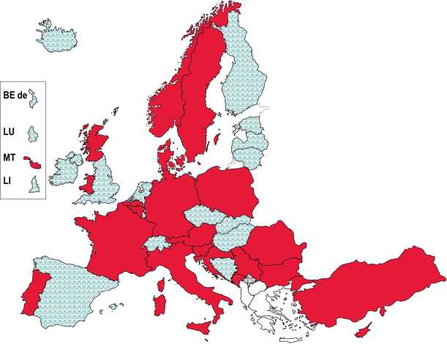Top-level steering documents covering higher education

higher education, 2017/18

**□ refer** explicitly to asylum seekers

and/or refugees

**do not refer** explicitly to asylum seekers and/or refugees

It is important to underline that in almost half of the systems, there is no mention of asylum seekers and/or refugees in top-level steering documents. This finding can be partially explained by two factors: firstly, despite two years - 2015 and 2016 - of unusually high numbers of asylum seekers coming to Europe, the vast majority settled in very few countries; and secondly, even in some countries which saw an increase in numbers, this social reality had little or no impact on top level higher education policy, with higher education institutions largely being left to manage the situation at their level.

*Source*: Eurydice.

1. Measures to support the integration of asylum seekers and refugees into higher education

Following the overview of strategic approaches for integrating newly arrived migrants into higher education, this section aims to outline the initiatives that have been taken at central/top level to implement the main policies. It considers firstly large-scale measures that have been developed specifically to respond to the needs of asylum seekers and refugees in higher education. It then examines the implementation of Article VII of the Lisbon Recognition Convention which focuses specifically on recognition of qualifications held by refugees, displaced persons and persons in a refugee-like situation. Finally, the section considers general access and participation measures targeting non-traditional learners. These measures - alternative routes to higher education and recognition of prior learning - would normally have been developed for a wider category of non- traditional learner than just asylum seekers and refugees. Nevertheless, such provision could be very relevant and helpful to asylum seekers and refugees who are interested in pursuing their higher education studies.

**2.2.1. Dedicated large-scale measures**

Where there is policy or strategy in place, authorities have the possibility to support their objectives through large-scale measures. This term refers to measures in the higher education sector that operate throughout the whole country or a significant geographical area rather than being developed for a particular higher education institution or geographical location. Figure 8 shows the countries where such measures exist.

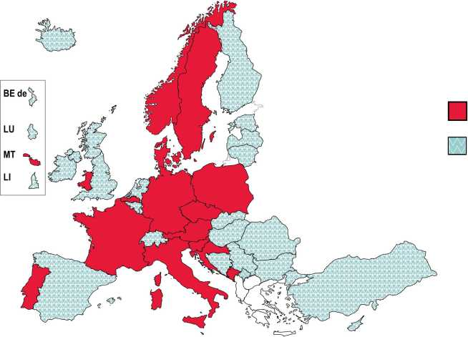

Figure 8: Large-scale measures to support the integration of asylum seekers and refugees into higher education, 2017/18

Such measures exist

No such measures

*Source*: Eurydice.

There are fewer systems that have large-scale measures for asylum seekers and refugees (16 systems) compared to the number of systems that mention asylum seekers and refugees in policy documents. The explanation of this finding is that not all countries mention asylum seekers or refugees in steering documents in relation to specific policy measures. Indeed, in some cases such documents may simply clarify that there is no top-level responsibility, and instead point out the bodies and institutions that may take initiatives in relation to asylum seekers and refugees. It is also worth pointing out that, as with the landscape for policy towards asylum seekers and refugees, some countries may have measures in place that are not specifically designed for facilitating access to higher education, but may have such an impact for some people. The Czech Republic, for example, points out that it has general language training and information services for asylum seekers and refugees. These services are not developed for refugees interested in entering higher education, but the services may benefit some refugees in this situation.

In the countries where measures can be found, they vary considerably in terms of the extent of their reflection and scope. Figure 9 outlines the main areas that have been addressed by measures.

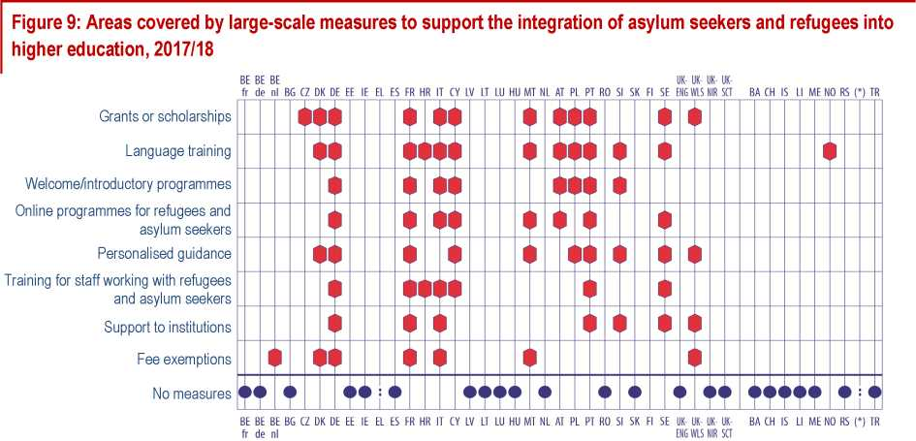

*Source:* Eurydice. (*) = The former Yugoslav Republic of Macedonia

Among the countries with large-scale measures, the provision of linguistic support is the most commonly identified element (13 systems). Twelve systems offer some kind of grant to asylum seekers or refugees, while six provide fee exemptions. The provision of personalised guidance is also fairly widespread - being found in ten systems. Training for staff in dealing with asylum seekers and refugees can be found in seven systems.

Germany is the country where the most complete package of measures can be found. The package is mostly managed by the German Academic Exchange Service (DAAD) - the organisation which has been delegated the responsibility to harness the potential of refugees who are qualified to study at German universities and facilitate access to German higher education. DAAD refugee programmes (see the case study) started at the beginning of 2016, and will run until 2019. The German Federal Ministry of Education and Research (BMBF) funds the measures.

**Case study: Germany - DAAD refugee programmes**

The DAAD programmes build upon a four-phase model: entrance, preparation, study and career. The programmes cover the first three phases and specifically address the challenges of identifying and recognising skills and potential, preparing students academically for higher education studies, and supporting integration into higher education institutions. The programmes have received 100 million Euro of funding by the Federal Ministry of Education and Research (BMBF) until 2019.

The measures aim to accelerate the university admission process of refugees, identifying their ability to study in Germany and helping to classify professional language skills. A number of tools well established for regular international students have been applied for this purpose, including bespoke student aptitude tests (TestAS for refugees) examining general and subject- related cognitive abilities. Web-based language tests have also been used as very good German (and sometimes English) language skills are required for higher education study. Higher education institutions have also been supported in running application and assessment processes.

A specific DAAD programme has been set up to integrate refugees into higher education: the INTEGRA programme has funded academic language and introductory courses at 170 universities and preparatory colleges. Indeed the majority of refugees have to pass language course before starting a regular degree programme. Originally planned for 2 400 refugees per year, the demand turned out to be much higher so that more than 10 400 places have been created annually.

Another strand of funding targets student-led volunteer projects supporting the integration of refugees into higher education. The programme provides funding for student assistants (8-10 hours per week), who are either in self-organised initiatives or form part of a university- organised support group. Activities aim to integrate refugees for example through tutorials, creation of information material, mentoring, translations, language training or more. Initiatives may also draw on the expertise of individual faculties (for example, legal advice of refugees by students in so-called Law Clinics). Funding is available for over 150 projects under this stream.

Finally, the DAAD has set-up information portals to give information and advice to refugees interested in university studies in Germany, as well as to higher education institutions and the public. The International DAAD Academy (iDA) provides professional training for university staff counselling refugee students.

In France, there is also an important set of measures that has been put together at central level. This includes grants and financial support to refugees, and also provides higher education institutions the autonomy to use financing to develop projects supporting the integration of asylum seekers and refugees.

In Sweden, special attention has been paid to the issue of recognition, and in particular to improving practice in recognising prior learning.

In Italy, 100 scholarships have been offered to refugees wishing to enter Italian higher education. This measure is financed by the Ministry of Interior Affairs and implemented by the Italian Rectors Conference. The Ministry of Education, Universities and Research also supports initiatives for the integration of refugees, and also in cooperation with the Rectors Conference. A similar approach has been taken in Portugal, with scholarships awarded to a number of Syrian refugee students and higher education institutions encouraged to develop their own actions.

In Malta, non-governmental organisations, which are typically funded through public donations, play an important role in the integration of asylum seekers and/or refugees into higher education. The measures targeted at asylum seekers and refugees include language training in English, and information sessions. Courses are also provided for people working with asylum seekers/refugees. Guidance is offered to all students in need in all higher education institutions, while asylum seekers can apply for fee waivers within the Ministry for Education and Employment.

In the Flemish Community of Belgium and Denmark, the measures refer only to an exemption of rules that are applied to international students with regard to fees. In this respect, refugees are treated in the same way as national citizens, with general student support funding used to implement this measure.

In the United Kingdom, Wales is the only nation that has developed a central strategy that includes measures to support asylum seekers and refugees in higher education. The Welsh Government provided funding in 2015-2017 to support Cardiff Metropolitan University in providing a monthly advice service offering asylum seekers and refugees guidance on possible routes into higher education. Between March and June 2018, the Welsh Government also consulted on a revised refugee and asylum seeker plan which continues to include the priority of increasing opportunities for asylum seekers and refugees to access further and higher education. The main elements of the plan include financial support, guidance and personal support.

In Croatia, there is a broad Action Plan (2017-2019) which refers, among a range of policy areas, to language learning and education. Here the objectives cover language learning, access to education and capacity building. The Action Plan also pushes for the shortest time period possible for refugees to be integrated into the education system, a supportive IT environment for enrolment into higher education institutions, and recognition of educational qualification and competences previously acquired, as well as for action giving refugees the opportunity to finish upper secondary school education. Moreover, although there is no right to financial support, persons who have been granted international protection and have enrolled in higher education institutions in Croatia can apply for student accommodation and state scholarships for students with lower social and economic status under the same conditions as Croatian citizens.

Slovenia is a particular case, having foreseen and planned a number of actions to support the integration of refugee students. However, the numbers of applications from refugees to higher education institutions has been so low that none of the foreseen actions has been undertaken.

1. **Implementation of Article VII of the Lisbon Recognition Convention**

Article VII of the Lisbon Recognition Convention (9) provides a legal framework for dealing with the recognition of qualifications held by refugees, displaced persons and persons in a refugee-like situation. It aims in particular to assist in situations where there can be a lack of established recognition procedures and policy for undocumented qualifications, documentary evidence of academic credentials and qualifications from the applicant, and information on legal obligations. The text states:

Each Party shall take all feasible and reasonable steps within the framework of its education system and in conformity with its constitutional, legal, and regulatory provisions to develop procedures designed to assess fairly and expeditiously whether refugees, displaced persons and persons in a refugee-like situation fulfil the relevant requirements for access to higher education, to further higher education programmes or to employment activities, even in cases in which the qualifications obtained in one of the Parties cannot be proven through documentary evidence.

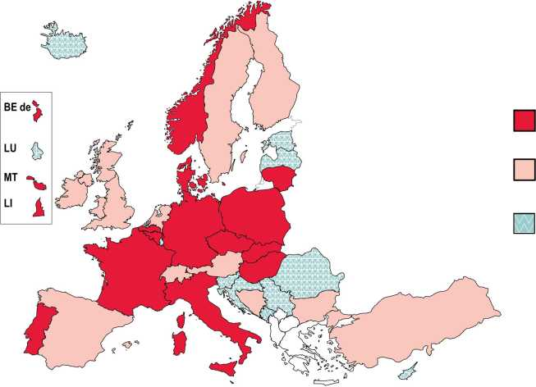

Figure 10: Implementation of article VII of the Lisbon Recognition Convention, 2017/18

Legally required

Not legally required but procedures are in place

Not legally required and procedures are not in place

*Source*: Eurydice.

All countries that have ratified the Lisbon Recognition Convention are required to develop procedures designed to assess fairly whether refugees fulfil the requirements to access higher education. The overall picture in Figure 10 shows, however, that the implementation of Article VII remains patchy Indeed, 10 systems have no legal requirement for specific recognition procedures for refugees, displaced persons and persons in a refugee-like situation, and they are not in place. However, among this group, Iceland is in the process of establishing appropriate procedures, and the Croatian 2017­2019 Action Plan for persons who have been granted international protection calls for a revision of recognition procedures.

In 16 systems there is a clear legal requirement for procedures to be followed. These systems include two - Italy and Malta - that are an important entry point for refugees to Europe. In the case of Malta, procedures are very practical, with refugees interviewed in reception centres and contact then made with the Malta Qualifications Recognition Information Centre (MQRIC). This body assists in finding out

1. Council of Europe Convention on the Recognition of Qualifications concerning Higher Education in the European Region,

ETS No.165. [Online] Available at:<http://www.coe.int/en/web/conventions/full-list/-/conventions/treaty/165> [Accessed 23 January 2019].

more about the qualifications which are claimed by refugees. Italy has very clear legislation and procedures for refugees and displaced persons with qualifications to follow.

In Norway, special procedures are in place for refugees and displaced persons that are without, or with incomplete, documentation. The most important is the Recognition Procedure for Persons without Verifiable Documentation ('UVD-procedure'). However, an alternative procedure, 'NOKUT's kvalifikasjonsvurdering', has been developed and follows the methodology of the European Qualifications Passport for Refugees (EQPR) developed by the Council of Europe. Both procedures are managed by the Norwegian Agency for Quality Assurance in Education (NOKUT), which is the Norwegian ENIC/NARIC.

Germany has set up procedures for accession of refugees to study programmes in case of missing documents including the use of student aptitude tests. Otherwise, the equivalence of foreign higher education entrance certificates is analysed as in the case of regular international students. In both cases, the DAAD is covering the fees.

Fourteen other systems have not outlined any legal procedures for the recognition of refugee qualifications but point out that procedures are nevertheless in place, and are used on a case by case basis.

**Case study: The Council of Europe European Qualifications Passport for Refugees (EQPR)**

10

The Council of Europe's European Qualifications for Passport for Refugees (EQPR) ( ) assesses refugees' qualifications even when they cannot be fully documented, thereby supporting their further studies, employment and integration. The methodology consists of a self-assessment questionnaire and interview with a team of two qualified credential evaluators to ensure a credible assessment. Based on the Lisbon Recognition Convention, Article VII and a specific Recommendation (11) adopted by the Convention Committee on 14 November 2017, the European Qualifications Passport for Refugees is steadily gaining acceptance among authorities and higher education institutions**.** Partners include Ministries of Education of Greece, Italy and Norway as host countries and/or financial supporters as well as National Recognition Centres from Armenia, Canada, France, Germany, Greece, Italy, the Netherlands, Norway and the United Kingdom. The Government of the Flemish Community of Belgium also contributes financially, and the UN Refugee Agency (UNHCR) is a privileged partner.

Thus far 287 interviews have taken place, with 221 EQPRs issued. Twenty one refugees have been accepted to universities. A pool of 25 credential evaluators from eight countries (Armenia, Canada, Germany, Greece, France, Italy, the Netherlands and Norway) has been trained in the EQPR methodology and between them have both a wide range of languages (Arabic, Dari/Farsi, English French, Italian, Russian) and knowledge of education systems.

1. For more details, see:<https://www.coe.int/en/web/education/recognition-of-refugees-qualifications> [Accessed 23 January 2019].
2. Recommendation on the recognition of refugees qualifications under the Lisbon Recognition Convention and Explanatory Memorandum. [Online] Available at: [https://rm.coe.int/recommendation-on-recognition-of-qualifications-held-by-refugees-](https://rm.coe.int/recommendation-on-recognition-of-qualifications-held-by-refugees-displ/16807688a8) [displ/16807688a8](https://rm.coe.int/recommendation-on-recognition-of-qualifications-held-by-refugees-displ/16807688a8) [Accessed 23 January 2019].
3. **General access and participation measures targeting non-traditional learners**

Alongside dedicated measures and procedures discussed in the previous sections, some measures targeting more widely non-traditional learners - regardless of their nationality - may potentially facilitate access for asylum seekers and refugees to higher education. Such measures include, in particular:

1. alternative routes to formal higher education entry qualifications;
2. possibilities for entering higher education without formal entry qualifications;
3. recognition of prior non-formal and informal learning for progression in higher education studies.

This section outlines the extent to which the above measures exist across Europe, providing an overview of the situation in Figure 11.

1. Alternative routes to formal higher education entry qualifications target either students who followed vocational educational or training tracks not giving access to higher education, or those who dropped out of school without obtaining an upper secondary school leaving certificate. They most commonly take the form of bridging programmes where a standard higher education entry qualification can be obtained. Alternatives to bridging programmes are higher education preparatory programmes or other programmes providing alternative qualifications to the upper secondary school leaving certificate. In any case, the completion of the programme leads to a formal qualification (a standard entry qualification or an alternative but comparable qualification) providing access to higher education. As Figure 11 shows, most European countries ensure this type of provision (12).
2. Those without a formal higher education entry qualification can potentially be entitled to enter higher education without such a qualification. As Figure 11 indicates, possibilities to enter higher education without formal qualifications exist in around half of all European countries, primarily in northern and western Europe. In most cases, the learner enters higher education based on the recognition of prior non-formal and informal learning. In some countries, however, the recognition procedure is supplemented by an additional entrance examination. Furthermore, besides the recognition of prior non-formal and informal learning, other forms of alternative access also exist in European countries: simple entrance examinations and preparatory or trial programmes. The latter are usually complementing frameworks for the recognition of prior non-formal and informal learning (13).
3. The recognition of prior non-formal and informal learning can be used beyond entry procedures to higher education. More specifically, prior learning activities can be recognised by higher education institutions as parts of study programmes (in the form of credits, for example), which in turn can help students to complete their higher education studies. At present, prior non-formal and informal learning can be recognised towards the fulfilment of higher education study programmes in the majority of European countries (see Figure 11). In most of them, this is made possible by a top-level framework, i.e. laws, regulations or other steering documents obliging higher education institutions to establish the relevant recognition procedures and/or guiding them in how to do so. In some higher education systems, higher education institutions have recognition procedures in place without the presence of a top-level framework (14).
4. As the 2018 Bologna Process Implementation Report specifies (European Commission/EACEA/Eurydice, 2018, p. 175, Figure 5.14), most countries provide 'bridging programmes', which lead to an upper secondary school leaving certificate. Higher education preparatory programmes providing alternative qualifications to the upper secondary school leaving certificate are less common. According to the above report, they exist only in Denmark, France and the United Kingdom.
5. For more details on different possibilities of accessing higher education without formal qualifications, and the distribution of these possibilities across Europe, see the 2018 Bologna Process Implementation Report (ibid., p. 176, Figure 5.15).
6. For more details on how regulations address the recognition of prior non-formal and informal learning for progression in higher education studies, see the 2018 Bologna Process Implementation Report (ibid., p. 208, Figure 5.38).

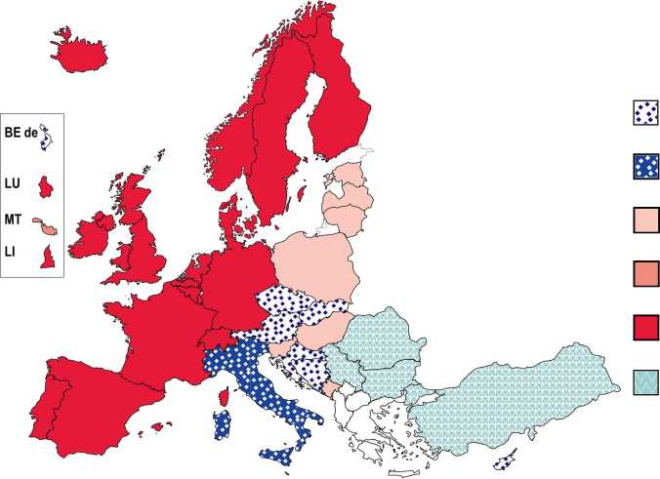

Figure 11: Higher education access and participation measures targeting non-traditional learners, 2017/18

A = Alternative routes to formal HE entry qualifications

B = Possibilities for entering HE without formal entry qualifications

A only

C only

A + C

B + C

A + B + C

None of the measures

**C** = Recognition of prior non-formal and informal learning for progression in HE studies

*Source:* Eurydice.

**Explanatory notes**

1. Alternative routes to formal higher education entry qualifications include: bridging programmes leading to a standard higher education entry qualification; higher education preparatory programmes or other programmes leading to alternative higher education entry qualifications. If a country provides at least one of the above measures, it is depicted on the figure.
2. Possibilities for entering higher education without formal entry qualifications include: entry through the recognition of prior non-formal and informal learning; entry through the recognition of prior non-formal and informal learning combined with an additional entrance exam; entrance exams/admission tests requiring no prior qualifications; entry through preparatory or trial higher education programmes. If a country provides at least one of the above measures, it is depicted on the figure.
3. Recognition of prior non-formal and informal learning for progression in higher education studies refers to situations where higher education institutions recognise prior non-formal and informal learning activities as parts of study programmes (in the form of credits, for example), which in turn can help students to complete their higher education studies.

As Figure 11 illustrates, the three types of measures described above co-exist in around half of all European countries. These countries - situated mainly in northern and western Europe - provide A) alternative access to formal higher entry qualifications, B) possibilities for entering higher education without formal qualifications, as well as C) opportunities for the recognition of prior learning for progression in higher education studies. Some other countries, which are mainly situated in the central region of Europe, offer only one or two of these options, excluding, in particular, access to higher education without formal entry qualifications. Finally, several countries situated mainly in south­eastern Europe do not have in place any access and participation measures discussed in this section.

1. Monitoring of participation of asylum seekers and refugees into higher education

Where there is clear national policy and/or measures in place to support the integration of asylum seekers and refugees, some form of top-level monitoring might be expected. Monitoring is understood in this context as the process of systematic data gathering, analysis and use of information by top­level authorities to feedback into the policy development process. This issue is examined in Figure 12.

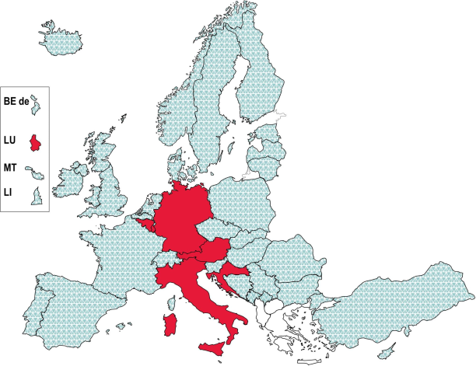*Source*: Eurydice. As the figure clearly illustrates, only a small minority of higher education systems monitor the integration of asylum seekers and refugees into higher education. Indeed, while 22 systems mention (at least one of) these two categories in legislation and 16 have measures, only six undertake monitoring. This gives an indication of the level of priority accorded to policy and measures in this area.

Figure 12: Monitoring of participation of asylum seekers and refugees in higher education, 2017/18

Participation of asylum seekers and refugees in higher education

| | is not monitored at top level

is subject to top-level monitoring

In terms of scale, there are extreme differences between the countries that collect data. At one end of the scale is Croatia, where only four refugee students are enrolled (although this number is expected to rise, as more refugees are known to be in secondary education). Meanwhile, in the French Community of Belgium, 70 students declared themselves as refugees in 2015/16 and in Luxembourg, 95 refugee students are currently enrolled. In Italy there are 356, while in Austria the number reaches 596.

The numbers in all of these countries are totally eclipsed by the situation in Germany, where over 6 000 refugee students are enrolled in first-cycle programmes, and more than10 400 in preparatory programmes.

Country data also show that there are many more male than female refugee students. In Germany, the ratio is 78 % male to 22 % female, and the same trends are apparent in the proportions in other countries.

Two other countries have related or partial data concerning asylum seekers and refugees in higher education. The Czech Republic has numbers of Syrian and Ukrainian refugee students studying in Czech higher education institutions - but only in relation to specific national initiatives. France has numbers of refugee applications for recognition of qualifications in relation to an application to higher education - 1 757 in 2017 and 2 052 in 2018. However, there is no data in either country on the overall numbers of refugee students studying in higher education.

CONCLUSIONS

In 2015 and 2016, immigration into Europe increased dramatically, with nearly 2.6 million people applying for asylum in a country of the European Union. Around half of all asylum applicants in the EU are aged between 18 and 34 - the age range typically associated with higher education.

Despite the recent experience of a significant increase in numbers of people seeking protection in Europe, this report shows that **the majority of countries have no specific policy approach to integrate asylum seekers and refugees into higher education**. Moreover, only a handful of countries have introduced higher education policy measures in response to increased numbers of refugees, and a similarly small number of countries monitor the integration of asylum seekers and refugees into higher education institutions.

These findings can partly be explained by the fact that **asylum requests have been concentrated in a limited number of European countries**. It is therefore only a few countries that have been dealing with substantial numbers of asylum seekers and refugees. In countries where numbers of asylum seekers and refugees are lower, some policy elements affecting higher education have been integrated into wider strategies on migration, and higher education institutions have mostly been left to respond in ways which suit their local context.

Although few countries have perceived or responded to a need for policy development and large-scale measures, there are national examples that could inspire future initiatives. **Germany stands out** in this respect, as its approach to the integration of asylum seekers and refugees **has combined policy making at several levels (federal, regional and at higher education institutions) with comprehensive measures implemented through responsible bodies, and with a clear monitoring system**. This thorough approach has undoubtedly ensured a much smoother process of integrating asylum seekers and refugees into appropriate higher education provision.

Where **large-scale measures** exist in European countries, they **most frequently focus on linguistic support, financial support and guidance services**.

**Recognition of previous educational attainment can be a serious challenge**, particularly when asylum seekers and refugees are unable to provide documentary evidence of their qualifications. This is the reason why a specific article on this topic was integrated into the Lisbon Recognition Convention - an overarching convention ratified by all countries involved in this report. **Yet despite the requirement for this article to be implemented through national legislation, this has not happened in 24 of the systems covered.** In ten of these systems no procedures been put in place for the recognition of qualifications held by refugees, displaced persons and persons in a refugee-like situation.

A number of **general access and participation measures** can be of great use to asylum seekers and refugees, especially: alternative routes to formal higher education entry qualifications; entry to higher education without formal entry qualifications; and the recognition of prior non-formal and informal learning for progression in higher education studies. Around **half of all European countries offer all these measures**, while most of the remaining countries provide only one or two of them. There are also countries - situated mainly in south-eastern Europe - providing none of these options.

Only **six higher education systems monitor the integration of asylum seekers and refugees** in their institutions. As monitoring is necessary to understand the impact of policy and measures, this finding confirms the low priority that integrating asylum seekers and refugees has had in most higher education systems.

GLOSSARY

**I. General terms related to higher education**

**Formal learning:** means learning which takes place in an organised and structured environment, specifically dedicated to learning, and typically leads to the award of a qualification, usually in the form of a certificate or a diploma. It includes systems of general education, initial vocational training and higher education (15).

**Higher education institution:** refers to any institution providing services in the field of higher and/or tertiary education, as defined by national law.

**Higher education qualification:** refers to any degree, diploma or other certificate issued by a competent authority attesting the successful completion of a higher education programme.

**Informal learning:** means learning resulting from daily activities related to work, family or leisure and is not organised or structured in terms of objectives, time or learning support; it may be unintentional from the learner's perspective; examples of learning outcomes acquired through informal learning are skills acquired through life and work experiences, project management skills or ICT skills acquired at work, languages learned and intercultural skills acquired during a stay in another country, ICT skills acquired outside work, skills acquired through volunteering, cultural activities, sports, youth work and through activities at home (e.g. taking care of a child) (16).

**Large-scale measure:** refers to a measure that operates throughout the whole country or a significant geographical area rather than a particular higher education institution or geographical location.

**Non-formal learning:** means learning which takes place through planned activities (in terms of learning objectives, learning time) where some form of learning support is present (e.g. student­teacher relationships); it may cover programmes to impart work skills, adult literacy and basic education for early school leavers; very common cases of non-formal learning include in-company training, through which companies update and improve the skills of their workers such as ICT skills, structured on-line learning (e.g. by making use of open educational resources), and courses organised by civil society organisations for their members, their target group or the general public (17).

**Recognition of non-formal and informal learning (in the context of higher education):** means validation and formal recognition of learners' non-formal and informal learning experiences in order to:

• provide higher education access to candidates without an upper secondary school leaving certificate; or

• within a higher education programme, allocate credits towards a qualification and/or provide exemption from some programme requirements.

**Steering document:** refers to an official document containing guidelines, obligations and/or recommendations for higher education policy and/or institutions.

**Strategy:** refers to an official policy document developed by top-level authorities in an effort to achieve an overall goal. A strategy can comprise a vision, identify objectives and goals (qualitative and quantitative), describe processes, authorities and people in charge, identify funding sources, make recommendations, etc.

**Top-level (authority, steering document, etc.):** is the highest level of authority with responsibility for education in a given country, usually located at national (state) level. However, for Belgium, Germany,

1. Council Recommendation of 20 December 2012 on the validation of non-formal and informal learning, O.J. 2012/C 398/01.
2. Ibid.
3. Ibid.

Spain and the United Kingdom, the *Communautes, Lander, Comunidades Autonomas* and devolved administrations respectively are responsible for all or most areas relating to education. Therefore, these administrations are considered as the top-level authority for the areas where they hold the responsibility, while for the ones for which they share the responsibility with the national (state) level, both are considered to be top-level authorities.

**Lisbon Recognition Convention (LRC):** refers to the Convention on the Recognition of Qualifications concerning Higher Education in the European Region (18) that was developed by the Council of Europe and UNESCO and adopted in 1997 in Lisbon.

**Monitoring:** refers to the process of systematic data gathering, analysis and use of information by top-level authorities to inform policy. Systematic monitoring must include mechanisms of cross- institutional data gathering and allow cross-institutional data comparability.

**II. Terms related to migratory flows**

**Asylum applicant/seeker:** means a person having submitted an application for international protection or having been included in such an application as a family member (based on Eurostat, 2015).

**Emigration:** the action by which a person, having previously been usually resident in the territory of a Member State, ceases to have his or her usual residence in that Member State for a period that is, or is expected to be, of at least 12 months (Eurostat, 2018b).

**First-time asylum applicant/seeker:** means a person having submitted an application for international protection for the first time. The term 'first-time' implies no time limits and therefore a person can be recorded as a first-time applicant only if he or she had never applied for international protection in the reporting country in the past, irrespective of the fact that he or she is found to have applied in another Member State of the European Union (based on Eurostat, 2015).

**Immigration:** refers to the action by which a person establishes his or her usual residence in the territory of a country for a period that is, or is expected to be, of at least 12 months, having previously been usually resident in another country (Eurostat, 2018b).

**International protection status:** includes:

* refugee status;
* subsidiary protection status;
* authorisation to stay for humanitarian reasons.

While refugee and subsidiary protection status are defined by EU law, humanitarian reasons are specific to national legislation and are not applicable in some of the EU Member States (for more details, see Eurostat, n.d.).

**Refugee:** means a third-country national who, owing to a well-founded fear of being persecuted for reasons of race, religion, nationality, political opinion or membership of a particular social group is outside the country of nationality and is unable or, owing to such fear, is unwilling to avail himself or herself of the protection of that country, or a stateless person, who, being outside of the country of former habitual residence for the same reasons as mentioned above, is unable or, owing to such fear, unwilling to return to it (based on Eurostat, 2017).

1. Council of Europe Convention on the Recognition of Qualifications concerning Higher Education in the European Region,

ETS No.165. [Online] Available at:<http://www.coe.int/en/web/conventions/full-list/-/conventions/treaty/165>

[Accessed 23 January 2019].

REFERENCES

European Commission, 2015. *State of the Union 2015 by Jean-Claude Juncker, President of the European Commission, 9 September 2015.* [pdf] Available at:

[https://ec.europa.eu/commission/sites/beta-political/files/state of the union 2015 en.pdf](https://ec.europa.eu/commission/sites/beta-political/files/state_of_the_union_2015_en.pdf)

[Accessed 6 December 2018].

European Commission/EACEA/Eurydice, 2018. *The European Higher Education Area in 2018: Bologna Process Implementation Report.* Luxembourg: Publications Office of the European Union.

Eurostat, 2015. *Glossary: Asylum applicant*. [Online] Available at: [https://ec.europa.eu/eurostat/statistics-explained/index.php?title=Glossary:Asylum applicant](https://ec.europa.eu/eurostat/statistics-explained/index.php?title=Glossary:Asylum_applicant) [Accessed 22 January 2019].

Eurostat, 2017. *Glossary: Refugee.* [Online] Available at: <https://ec.europa.eu/eurostat/statistics-explained/index.php/Glossary:Refugee> [Accessed 22 January 2019].

Eurostat, 2018a. *Asylum statistics.* [Online] Available at: [https://ec.europa.eu/eurostat/statistics-explained/index.php/Asylum statistics](https://ec.europa.eu/eurostat/statistics-explained/index.php/Asylum_statistics) [Accessed 8 October 2018].

Eurostat, 2018b. *Glossary: Migration*. [Online] Available at: <https://ec.europa.eu/eurostat/statistics-explained/index.php/Glossary:Migration> [Accessed 22 January 2019].

Eurostat, 2018c. *Migration and migrant population statistics.* [Online] Available at: [https://ec.europa.eu/eurostat/statistics-](https://ec.europa.eu/eurostat/statistics-explained/index.php/Migration_and_migrant_population_statistics%23Migration_flows:_2_million_non-EU_immigrants)

[explained/index.php/Migration and migrant population statistics#Migration flows: 2 million non­EU immigrants](https://ec.europa.eu/eurostat/statistics-explained/index.php/Migration_and_migrant_population_statistics%23Migration_flows:_2_million_non-EU_immigrants) [Accessed 11 December 2018].

Eurostat, n.d. *Glossary: Asylum decision.* [Online] Available at: [https://ec.europa.eu/eurostat/statistics-explained/index.php?title=Glossary:Asylum decision](https://ec.europa.eu/eurostat/statistics-explained/index.php?title=Glossary:Asylum_decision) [Accessed 22 January 2019].

KMK (Kultusministerkonferenz) [Standing Conference of the Ministers of Education and Cultural Affairs (DE)], 2015. *Hochschulzugang und Hochschulzulassung fur Studienbewerberinnen bzw. Studienbewerber, die fluchtbedingt den Nachweis der im Heimatland erwor-benen*

*Hochschulzugangsberechtigung nicht erbringen konnen (Beschluss der Kultusministerkonferenz vom 03.12.2015)* [Access and Admission to Institutions of Higher Education for Applicants who are Unable to Provide Evidence of a Higher Education Entrance Qualification Obtained in their Home Country on Account of their Flight (Resolution of the Standing Conference of the Ministers of Education and Cultural Affairs dated 3 December 2015)]. [pdf] Available at: [https://www.kmk.org/fileadmin/Dateien/veroeffentlichungen beschluesse/2015/2015 12 03-](https://www.kmk.org/fileadmin/Dateien/veroeffentlichungen_beschluesse/2015/2015_12_03-Hochschulzugang-ohne-Nachweis-der-Hochschulzugangsberechtigung.pdf)

[Hochschulzugang-ohne-Nachweis-der-Hochschulzugangsberechtigung.pdf](https://www.kmk.org/fileadmin/Dateien/veroeffentlichungen_beschluesse/2015/2015_12_03-Hochschulzugang-ohne-Nachweis-der-Hochschulzugangsberechtigung.pdf)

[Accessed 22 January 2018].

ACKNOWLEDGEMENTS

**EDUCATION, AUDIOVISUAL AND CULTURE  
EXECUTIVE AGENCY**

**Education and Youth Policy Analysis**

Avenue du Bourget 1 (J-70 - Unit A7)  
B-1049 Brussels  
(<http://ec.europa.eu/eurydice>)

**Managing editor**

Arlette Delhaxhe

**Authors**

David Crosier (coordination) and Daniela Kocanova

**Layout and graphics**

Patrice Brel

**Layout of the cover**

Virginia Giovannelli

**Production coordinator**

Gisele De Lel

**EURYDICE NATIONAL UNITS**

**ALBANIA**

Eurydice Unit

European Integration and International Cooperation

Department of Integration and Projects

Ministry of Education and Sport

Rruga e Durresit, Nr. 23

1001 Tirane

**AUSTRIA**

Eurydice-Informationsstelle

Bundesministerium fur Bildung, Wissenschaft und Forschung

Abt. Bildungsstatistik und -monitoring

Minoritenplatz 5

1010 Wien

Contribution of the Unit: Joint responsibility

**BELGIUM**

Unite Eurydice de la Communaute franpaise Ministere de la Federation Wallonie-Bruxelles Direction des relations internationales

Boulevard Leopold II, 44 - Bureau 6A/008

1080 Bruxelles

Contribution of the Unit: Joint responsibility

Eurydice Vlaanderen

Departement Onderwijs en Vorming/

Afdeling Strategische Beleidsondersteuning

Koning Albert II-laan 15

1210 Brussel

Contribution of the Unit: Pieter-Jan De Vlieger

Eurydice-Informationsstelle der Deutschsprachigen Gemeinschaft

Ministerium der Deutschsprachigen Gemeinschaft

Fachbereich Ausbildung und Unterrichtsorganisation Gospertstralie 1

4700 Eupen

Contribution of the Unit: Xavier Hurlet

**CZECHIA**

Eurydice Unit

Centre for International Cooperation in Education

Dum zahranicni spoluprace

Na Poffdf 1035/4

110 00 Praha 1

Contribution of the Unit: Jana Halamova, Helena PavKkova; Lukas Seifert, Lucie Trojanova (experts from the MEYS)

**DENMARK**

Eurydice Unit

Ministry of Higher Education and Science

The Danish Agency for Research and Higher Education Bredgade 40

1260 K0benhavn K

Contribution of the Unit: The Ministry of Higher Education and Science

**ESTONIA**

Eurydice Unit

Analysis Department

Ministry of Education and Research

Munga 18

50088 Tartu

Contribution of the Unit: Kersti Kaldma (coordination); expert: Viivian Joemets (chief expert, General Education Department, Ministry of Education and Research)

**FINLAND**

**BOSNIA AND HERZEGOVINA**

Eurydice Unit

Finnish National Agency for Education

P.O. Box 380

00531 Helsinki

Contribution of the Unit: Sinikka Tamminen (senior adviser), Hanna Laakso (senior adviser), Sofia Mursula (specialist)

**FORMER YUGOSLAV REPUBLIC OF MACEDONIA**

Ministry of Civil Affairs

Education Sector

Trg BiH 3

71000 Sarajevo

Contribution of the Unit: Joint responsibility

National Agency for European Educational Programmes and Mobility

Porta Bunjakovec 2A-1

1000 Skopje

**FRANCE**

**BULGARIA**

Eurydice Unit

Human Resource Development Centre Education Research and Planning Unit 15, Graf Ignatiev Str.

1000 Sofia

Contribution of the Unit: Ivana Radonova

**CROATIA**

Unite franpaise d'Eurydice

Ministere de l'Education nationale et de la Jeunesse (MENJ- DEPP-MIREI)

Ministere de l'Enseignement superieur, de la Recherche et de l'Innovation (MESRI)

61-65, rue Dutot

75732 Paris Cedex 15

Contribution of the Unit: Helene Bessieres (expert), Marine Gobet et Catherine Chapel (MESRI-DGESIP-DGRI-DAEI)

Agency for Mobility and EU Programmes

Frankopanska 26

10000 Zagreb

Contribution of the Unit: Joint responsibility

**GERMANY**

**CYPRUS**

Eurydice Unit

Ministry of Education and Culture

Kimonos and Thoukydidou

1434 Nicosia

Contribution of the Unit: Christiana Haperi; expert: Christakis Kalogirou (Department of Higher Education, Ministry of Education and Culture)

Eurydice-Informationsstelle des Bundes

Deutsches Zentrum fur Luft- und Raumfahrt e. V. (DLR) Heinrich-Konen Str. 1 53227 Bonn

Contribution of the Unit: Bernd Fischer (Federal Ministry of Education and Research) and Linda Dieke (Eurydice National Unit - Bund) at DLR Project Management Agency

Eurydice-Informationsstelle der Lander im Sekretariat der Kultusministerkonferenz

Taubenstraie 10 10117 Berlin

Contribution of the Unit: Thomas Eckhardt

**GREECE**

Eurydice Unit

Directorate of European and International Affairs General Directorate for International, European Affairs, Education for Greeks Abroad, Intercultural Education Ministry of Education, Research and Religious Affairs 37 Andrea Papandreou Str. (Office 2172) 15180 Maroussi (Attiki)

Eurydice Unit

National Agency for School Evaluation of the Republic of Lithuania

Gelezinio Vilko Street 12

03163 Vilnius

Contribution of the Unit: Joint responsibility of the Unit

**LUXEMBOURG**

**HUNGARY**

Hungarian Eurydice Unit

Educational Authority

10-14 Szalay utca

1055 Budapest

Contribution of the Unit: Sara Hatony

**ICELAND**

Unite nationale d'Eurydice

ANEFORE ASBL

eduPole Walferdange

Batiment 03 - etage 01

Route de Diekirch

7220 Walferdange

Contribution of the Unit: Expert: Corinne Kox (Ministry of Higher Education and Research)

Eurydice Unit

The Directorate of Education

V^kurhvarfi 3

203 Kopavogur

Contribution of the Unit: Hulda Skogland (expert, Department of Analysis)

**MALTA**

**IRELAND**

Eurydice Unit

Department of Education and Skills

International Section

Marlborough Street

Dublin 1 - DO1 RC96

Contribution of the Unit: Joint responsibility

Eurydice National Unit

Directorate for Research, Lifelong Learning and Employability

Ministry for Education and Employment

Great Siege Road

Floriana VLT 2000

Contribution of the Unit: Sefora Borg and the Eurydice Unit

**MONTENEGRO**

**ITALY**

Eurydice Unit

Vaka Djurovica bb

81000 Podgorica

Contribution of the Unit: NU Montenegro

Unita italiana di Eurydice

Istituto Nazionale di Documentazione, Innovazione e Ricerca Educativa (INDIRE)

Agenzia Erasmus+

Via C. Lombroso 6/15

50134 Firenze

Contribution of the Unit: Alessandra Mochi;

expert: Paola Castellucci (Direzione generale per lo studente, lo sviluppo e l'internazionalizzazione della formazione superiore - Ministero dell'Istruzione, dell'Universita e della Ricerca)

**NETHERLANDS**

Eurydice Nederland

Ministerie van Onderwijs, Cultuur en Wetenschap Directie Internationaal Beleid

Rijnstraat 50

2500 BJ Den Haag

Contribution of the Unit: Joint responsibility

**NORWAY**

**LATVIA**

Eurydice Unit

State Education Development Agency

Valnu street 1 (5th floor)

1050 Riga

Contribution of the Unit: Joint responsibility

Eurydice Unit

Ministry of Education and Research

AIK-avd., Kunnskapsdepartementet

Kirkegata 18

P.O. Box 8119 Dep.

0032 Oslo

Contribution of the Unit: Shared responsibility

**POLAND**

**LITHUANIA**

**LIECHTENSTEIN**

Informationsstelle Eurydice

Schulamt des Furstentums Liechtenstein

Austrasse 79

Postfach 684

9490 Vaduz

Contribution of the Unit: Joint responsibility

Polish Eurydice Unit

Foundation for the Development of the Education System

Aleje Jerozolimskie 142A

02-305 Warszawa

Contribution of the Unit: Expert: dr Mariusz Luterek (University of Warsaw); coordination: Magdalena Gorowska- Fells in consultation with the Ministry of Science and Higher Education

**PORTUGAL**

Unidade Portuguesa da Rede Eurydice (UPRE) Ministerio da Educapao e Ciencia Direpao-Geral de Estatfsticas da Educapao Av. 24 de Julho, 134

1399-054 Lisboa

Contribution of the Unit: Joint responsibility

**ROMANIA SWEDEN**

Eurydice Unit

National Agency for Community Programmes in the Field of Education and Vocational Training

Universitatea Politehnica Bucuresti

Biblioteca Centrala

Splaiul Independentei, nr. 313

Sector 6

060042 Bucuresti

Contribution of the Unit: Veronica - Gabriela Chirea in cooperation with experts from the Institute of Science Education: Ciprian Fartusnic and Adela Mihaela Taranu

**SERBIA**

Eurydice Unit Serbia

Foundation Tempus

Ruze Jovanovic 27a

11000 Belgrade

Contribution of the Unit: Joint responsibility

**SLOVAKIA**

Eurydice Unit

Slovak Academic Association for International Cooperation Knzkova 9

811 04 Bratislava

Contribution of the Unit: Martina Rackova

**SLOVENIA**

Eurydice Unit

Ministry of Education, Science and Sport

Education Development Office

Masarykova 16

1000 Ljubljana

Contribution of the Unit: Barbara Kresal Sternisa; expert:

Sasa Zabukovec (Ministry of Education, Science and Sport)

**SPAIN**

Eurydice Espana-REDIE

Centro Nacional de Innovacion e Investigacion Educativa (CNIIE)

Ministerio de Educacion y Formacion Profesional c/ Torrelaguna, 58

28027 Madrid

Contribution of the Unit: Marta Crespo Petit, Ana Prados Gomez, Rosa Mana Molina Martinez-Risco, Ricardo Martinez Zamorano and Elena Vazquez Aguilar

Eurydice Unit

Universitets- och hogskoleradet/

The Swedish Council for Higher Education

Box 450 93

104 30 Stockholm

Contribution of the Unit: Madelen.Charysczak

**SWITZERLAND**

Eurydice Unit

Swiss Conference of Cantonal Ministers of Education (EDK) Speichergasse 6

3001 Bern

Contribution of the Unit: Joint responsibility

**TURKEY**

Eurydice Unit

MEB, Strateji Geli^tirme Ba^kanligi (SGB) Eurydice Turkiye Birimi, Merkez Bina 4. Kat B-Blok Bakanliklar

06648 Ankara

Contribution of the Unit: Osman Yildirim

**UNITED KINGDOM**

Eurydice Unit for England, Wales and Northern Ireland National Foundation for Educational Research (NFER) The Mere, Upton Park

Slough, Berkshire, SL1 2DQ

Contribution of the Unit: Sharon O'Donnell and Hilary Grayson

Eurydice Unit Scotland

Learning Directorate

Scottish Government

2-C North

Victoria Quay

Edinburgh EH6 6QQ

Contribution of the Unit: Ed Thomson, Jackie Walder and Gary Walsh

EC-04-19-078-EN-N

**Integrating Asylum Seekers and Refugees into Higher Education in Europe: National Policies and Measures**

What role did higher education play in addressing the refugee crisis? Many asylum seekers and refugees entering Europe in 2015 and 2016 were in the typical higher education age range and had been enrolled in university programmes in their home country. However, while continuing to study may be beneficial both for individuals and for host countries, integrating people who have escaped major conflict, who may be traumatised and who may lack language and other skills is far from a simple task.

You will discover that in a majority of countries there is no specific policy approach on this matter and that only six higher education systems monitor the integration of asylum seekers and refugees into their institutions. Nevertheless, good practice can be found in a few countries on issues such as recognition of undocumented qualifications, support to language learning, provision of financial support and personal guidance services.

The aim of this report, planned in the wake of two years of increased levels of migration, is to assess to what extent national systems have developed policy and measures to respond to the needs of asylum seekers and refugees. The report is divided into two parts: the first presents a selection of indicators on migratory flows; the second part offers an overview of policies and strategies across 35 European countries for the integration of asylum seekers and refugees into higher education.

The Eurydice Network's task is to understand and explain how Europe's different education systems are organised and how they work. The network provides descriptions of national education systems, comparative studies devoted to specific topics, indicators and statistics. All Eurydice publications are available free of charge on the Eurydice website or in print upon request. Through its work, Eurydice aims to promote understanding, cooperation, trust and mobility at European and international levels. The network consists of national units located in European countries and is co-ordinated by the EU Education, Audiovisual and Culture Executive Agency. For more information about Eurydice, see <http://ec.europa.eu/eurydice>.

|  |  |  |  |  |
| --- | --- | --- | --- | --- |
|  | |  |  | |
|  |  | ***  ★ ★  ★ ★  ***** |  |  |
|  | |  |  | |

ISBN 978-92-9492-916-7

doi:10.2797/548910

